UNIVERSITY OF AGRICULTURAL SCIENCES
College of Agriculture, GKVK, Bangalore – 560065
EAI-421: Artificial Intelligence & Machine Learning in Agriculture (0+10)

Weather-Based Price
Prediction Model
Onion · Tomato · Chilli

Student IDs: AMB2207 | AMB2173
April 2026

1. Introduction
Agriculture commodity prices are among the most volatile variables in the modern economy. When prices fall too low, the farming community suffers; when they rise too high, the consumer market is disrupted. A stable price band that satisfies both producers and consumers is therefore a critical policy goal.

Commodity prices are driven by a complex set of interacting factors: demand and supply dynamics, weather patterns, government policies, seasonal cycles, geopolitical events, and unforeseen crises. This project presents a simulated price-prediction model for three high-impact vegetables — Onion, Tomato, and Chilli — by correlating historical market prices with weather data. The work serves as a proof-of-concept for a broader global agricultural commodity price prediction framework.

2. Problem Statement
Key challenges addressed by this project:
- Instability and unpredictability of agricultural produce prices
- Inherent seasonality in production cycles
- Highly variable and difficult-to-forecast weather conditions
- Limited farmer awareness of current and future supply-demand trends

Project Goal: Develop a machine learning model that predicts future agriculture commodity prices and market trends based on weather variables and seasonal patterns.

3. Objectives
- Develop an ML model to predict future prices of key agricultural produce.
- Create awareness among farmers about anticipated market prices.
- Generate seasonal crop-planning guidance to help farmers decide what to grow and when.
- Support informed warehouse storage decisions based on assured price forecasts.
- Contribute toward national price stabilisation using a grid-based prediction system.

4. Dataset Overview
The dataset spans ten years (April 2016 – April 2026) and captures daily weather and vegetable price readings for India.

4.1 Weather Variables
- Temperature (°C) — India daily average
- Rainfall (mm) — India daily average
- Humidity (%) — India daily average

4.2 Price Variables
- Onion (Rs/kg)
- Tomato (Rs/kg)
- Chilli (Rs/kg)

4.3 Data Sources
Weather data: NOAA, NASA POWER, OpenWeather, Meteostat
Price data: AGMARKNET, FAOSTAT Dataset, World Bank Commodity Prices

5. Methodology
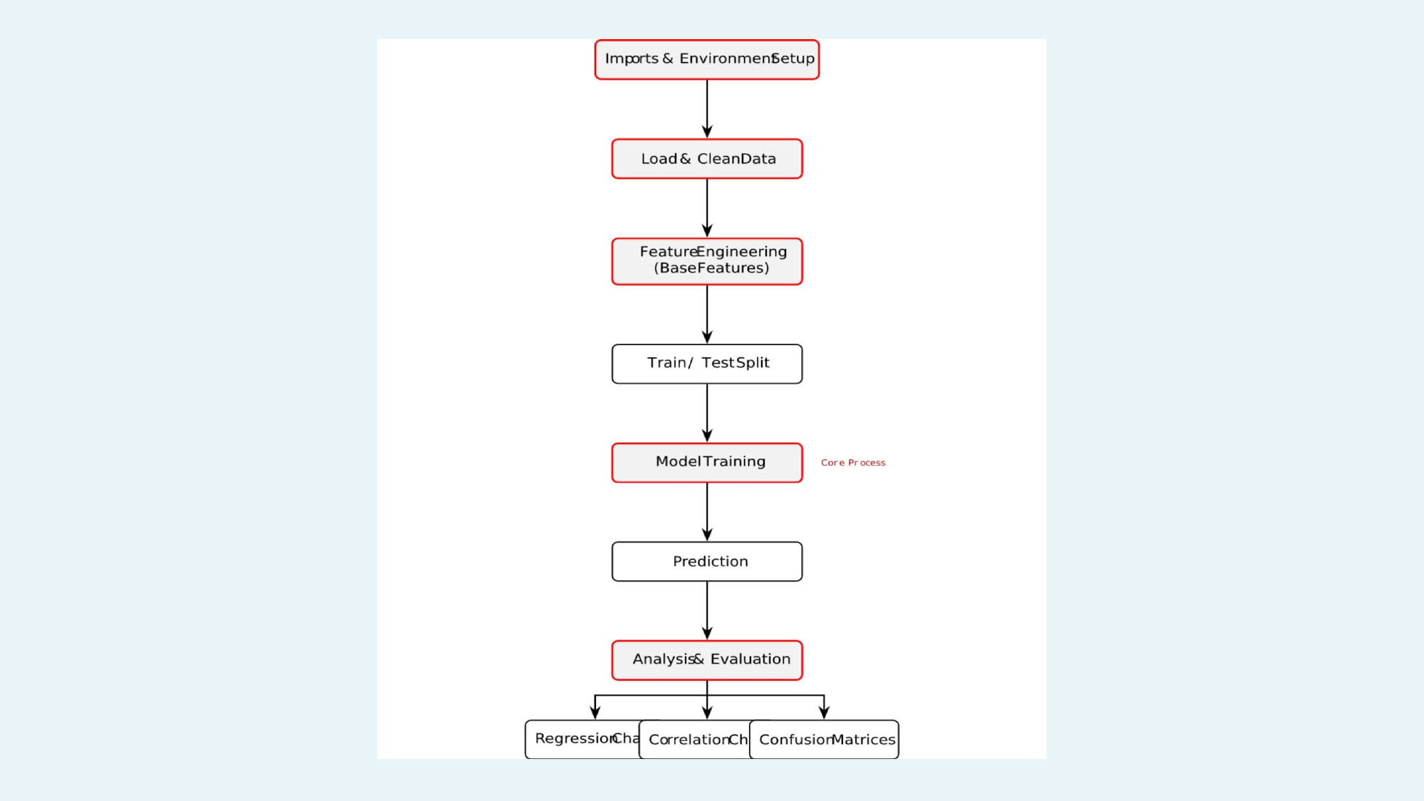
Figure 1 — ML Pipeline: from data ingestion to evaluation

5.1 Data Preprocessing
- Dataset uploaded and cleaned in Google Colab
- Feature selection: Rainfall, Temperature, Humidity
- Normalisation and train-test split (80:20)

5.2 Exploratory Data Analysis
- Correlation heatmap to identify key weather-price relationships
- Seasonal trend analysis across months and years

5.3 Model Selection & Training
Three classification and regression algorithms were evaluated:
- Random Forest (primary — ensemble of decision trees)
- Decision Tree Classifier
- Logistic Regression

5.4 Evaluation Metrics
- Regression: MAE, RMSE, R² Score
- Classification: Accuracy, Precision, Recall, F1-Score, Confusion Matrix

6. Tools & Technologies
Tool / Technology | Role in Project
Python 3.x | Core programming language for the ML pipeline
pandas | Data loading, manipulation, and preprocessing
NumPy | Numerical computations and array operations
matplotlib | Visualisation — bar charts, heatmaps, regression plots
scikit-learn | ML model building and evaluation
Random Forest Classifier | Primary ensemble model for classification and regression
Decision Tree Classifier | Tree-based rule model for classification
Logistic Regression | Baseline binary classification (Safe / Unsafe pricing)
train_test_split | 80/20 dataset partitioning
Confusion Matrix | Classification performance evaluation

7. Results

7.1 Correlation Analysis
The heatmap below quantifies the relationship between weather variables and vegetable prices.
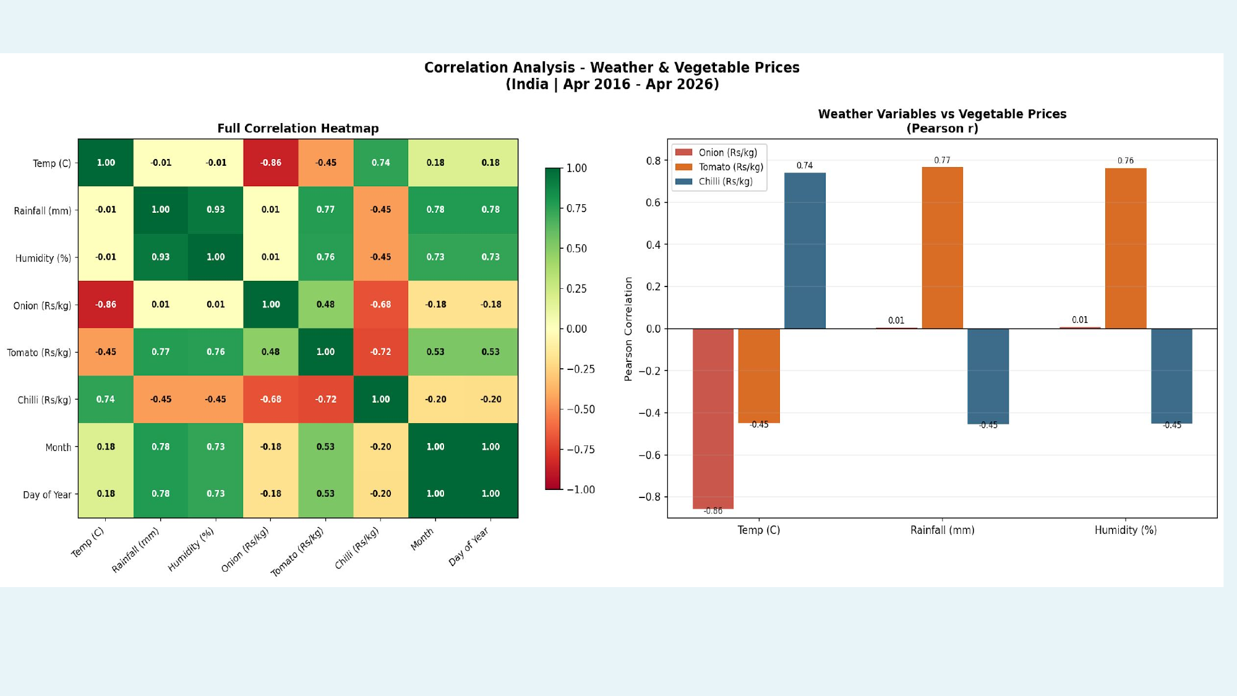
Figure 2 — Correlation Analysis: Weather Variables vs Vegetable Prices (2016–2026)

7.2 Model Evaluation Summary
All three vegetables were modelled using Random Forest with an 80/20 train-test split across 3,682 data points.

Vegetable | MAE (Rs/kg) | RMSE (Rs/kg) | R² Score | Classifier Acc.
Onion | 3.86 | 4.86 | 0.9041 | 81.14%
Tomato | 5.16 | 7.07 | 0.8829 | 83.18%
Chilli | 9.23 | 11.58 | 0.8565 | 79.78%

7.3 Confusion Matrices
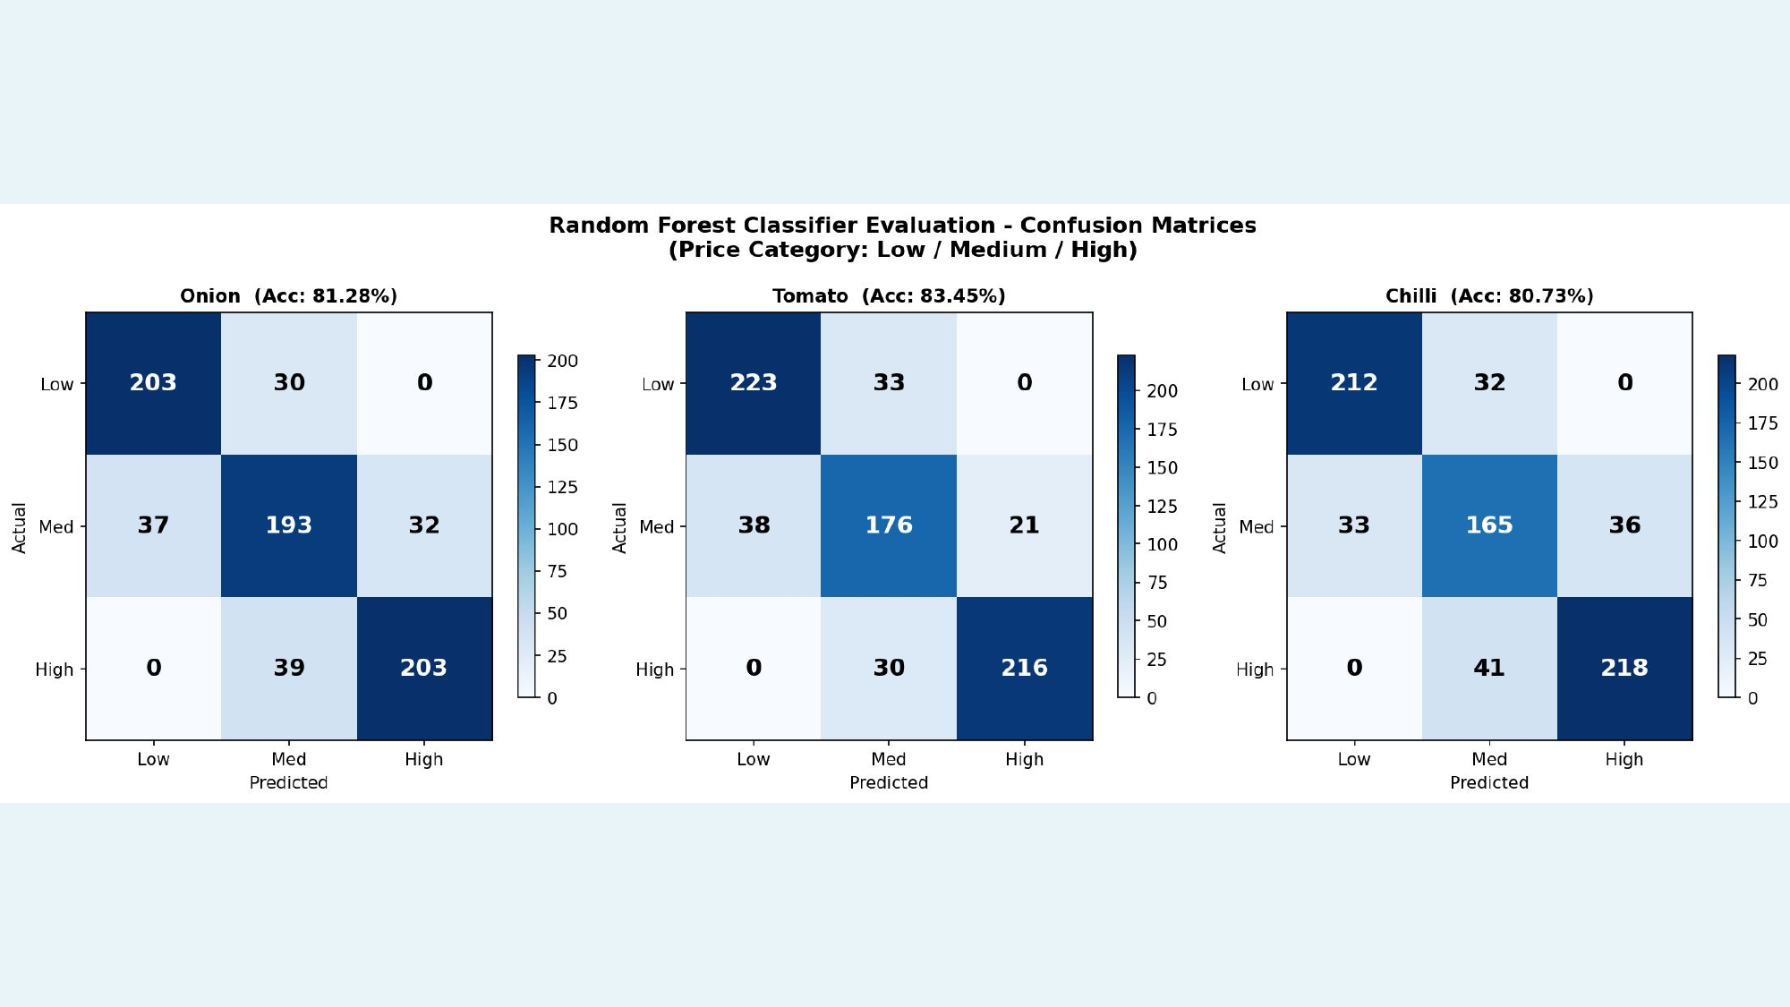
Figure 3 — Random Forest Classifier Confusion Matrices (Low / Medium / High price categories)

7.4 Regression Analysis Charts

Onion Price Analysis
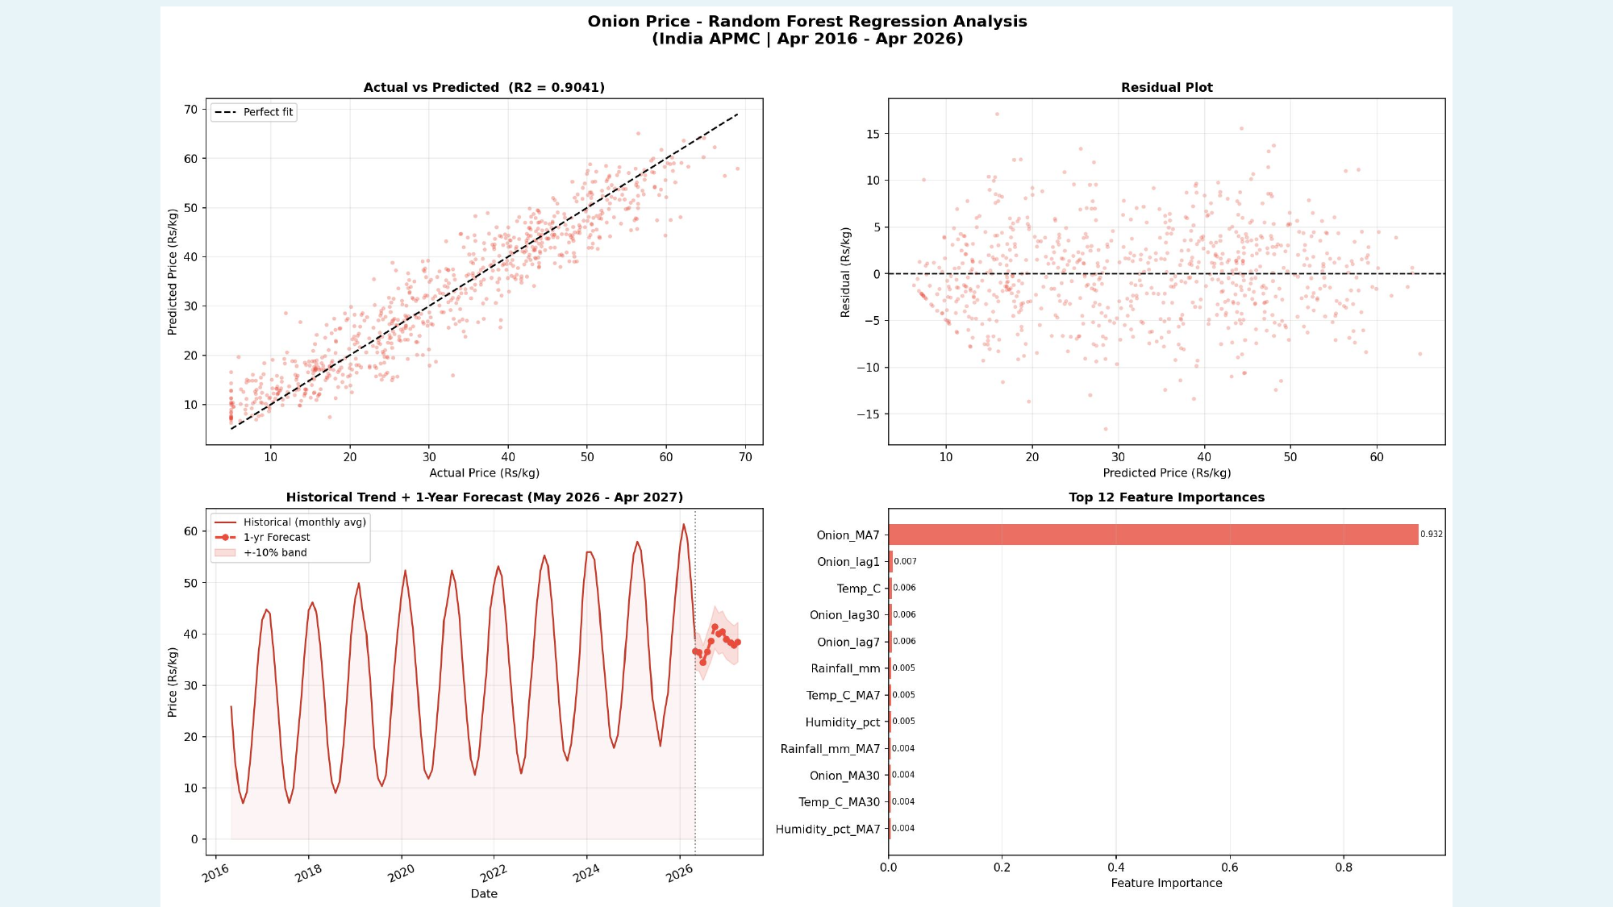
Figure 4 — Onion Price: Random Forest Regression Analysis (R² = 0.9041)

Tomato Price Analysis
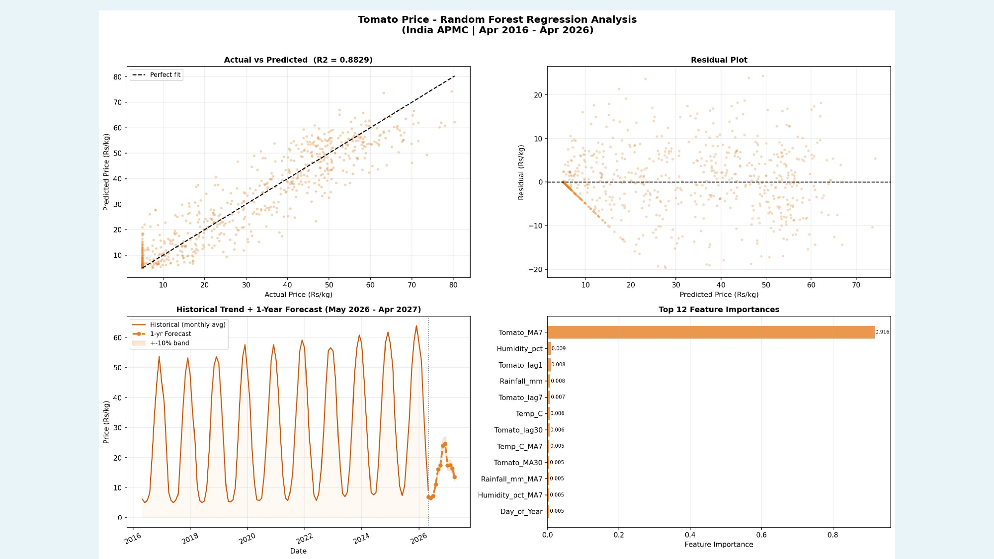
Figure 5 — Tomato Price: Random Forest Regression Analysis (R² = 0.8829)

Chilli Price Analysis
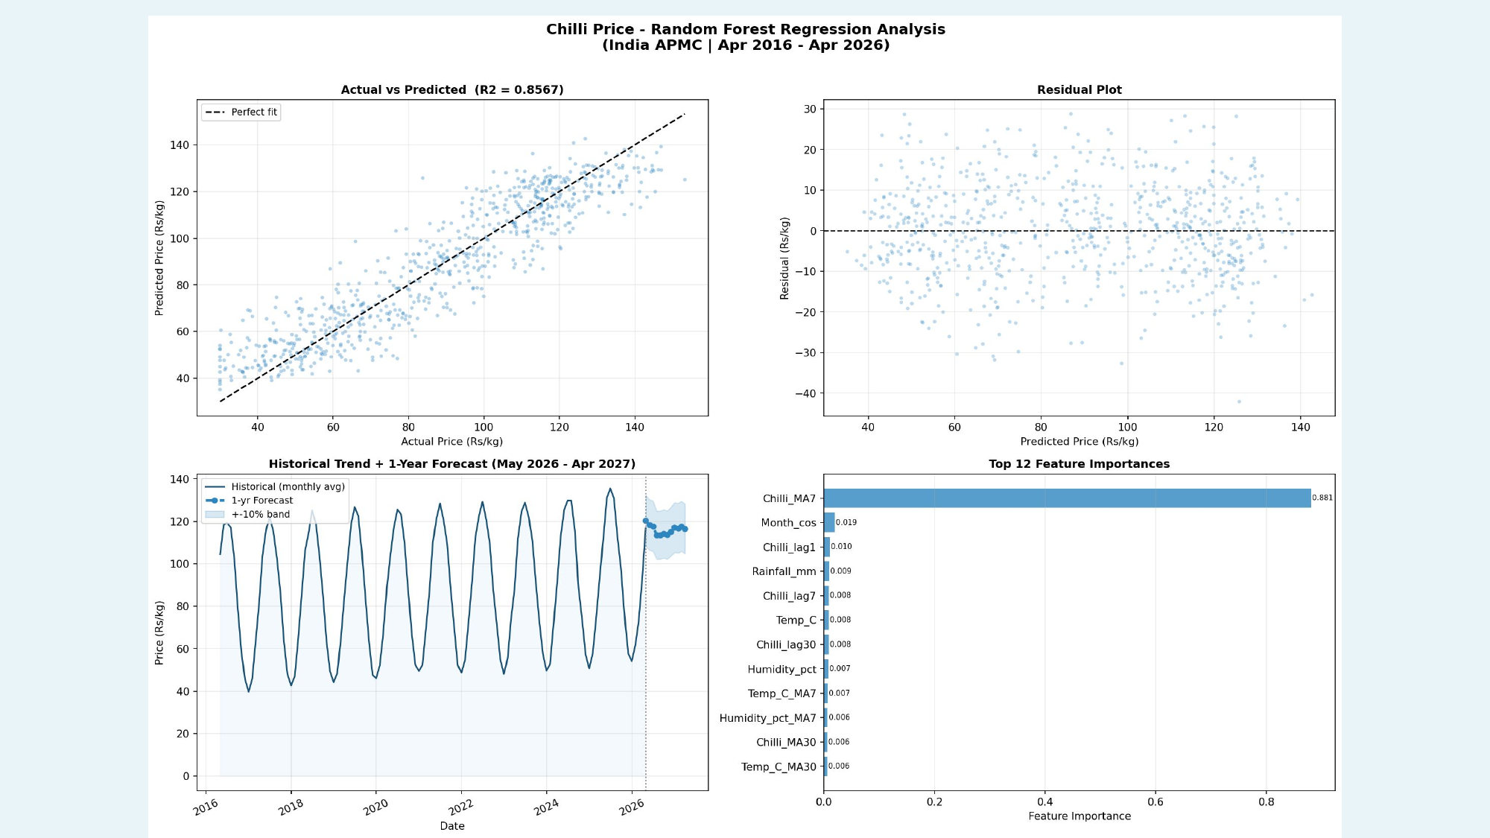
Figure 6 — Chilli Price: Random Forest Regression Analysis (R² = 0.8565)

7.5 One-Year Price Forecast (May 2026 – April 2027)
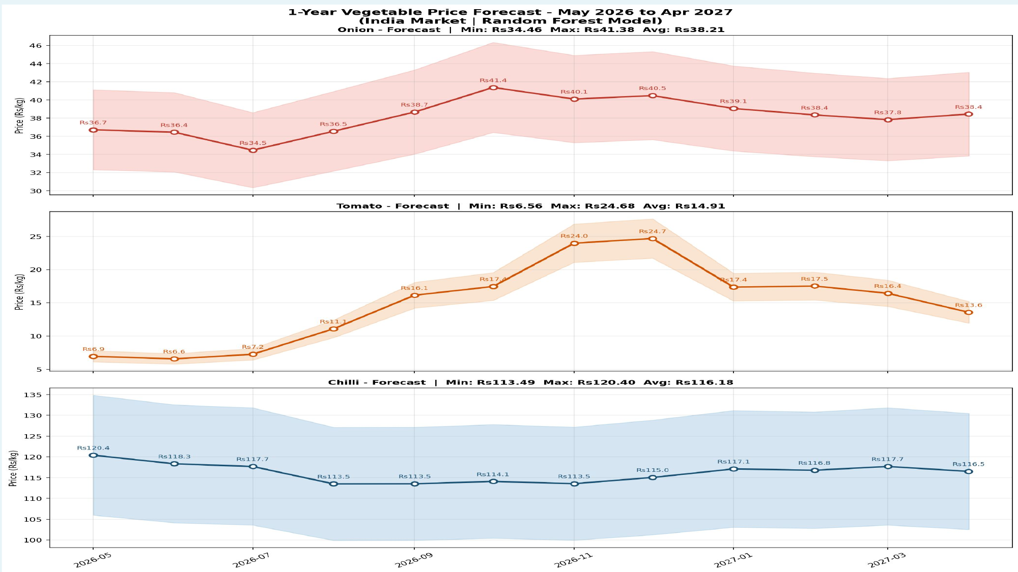
Figure 7 — 1-Year Vegetable Price Forecast: May 2026 to April 2027

Month | Onion (Rs) | Tomato (Rs) | Chilli (Rs) | Temp (°C) | Rain (mm)
May 2026 | 36.76 | 6.94 | 120.12 | 32.2 | 7.9
Jun 2026 | 36.43 | 6.56 | 118.33 | 34.8 | 6.9
Jul 2026 | 34.46 | 7.25 | 117.31 | 36.0 | 48.0
Aug 2026 | 36.55 | 11.09 | 113.44 | 35.1 | 87.8
Sep 2026 | 38.67 | 16.14 | 113.86 | 32.2 | 117.1
Oct 2026 | 41.38 | 17.45 | 113.99 | 28.0 | 127.6
Nov 2026 | 40.10 | 23.97 | 113.12 | 23.9 | 116.3
Dec 2026 | 40.62 | 24.68 | 115.17 | 21.1 | 87.4
Jan 2027 | 39.01 | 17.36 | 117.38 | 20.3 | 48.4
Feb 2027 | 38.28 | 17.52 | 116.65 | 21.1 | 7.7
Mar 2027 | 37.81 | 16.43 | 117.82 | 24.0 | 8.1
Apr 2027 | 38.44 | 13.57 | 116.33 | 28.1 | 8.4

7.6 Global Price Dashboard
The following dashboard illustrates a conceptual extension of the model to global onion price monitoring across major producing and consuming nations.
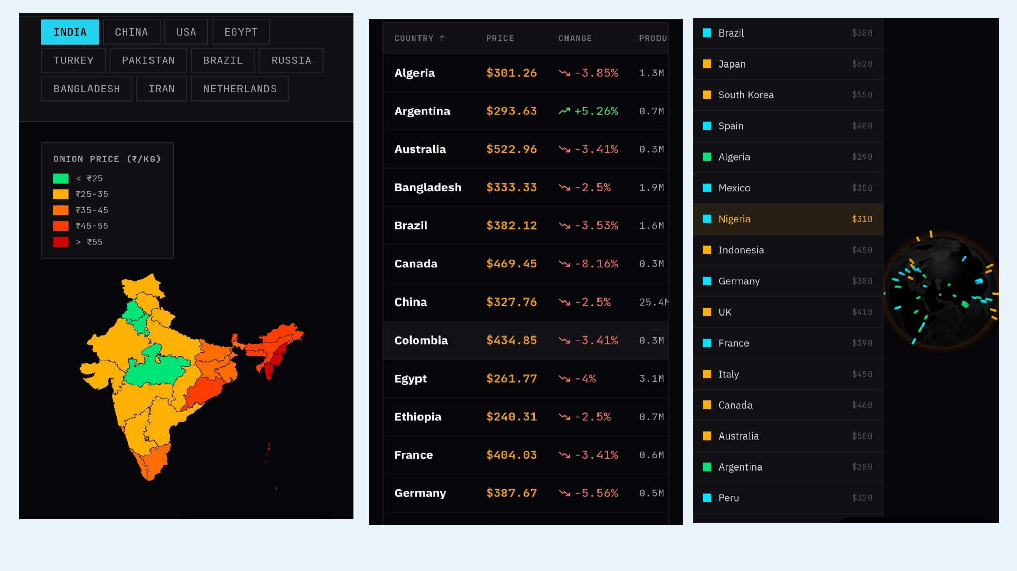
Figure 8 — Global Commodity Price Dashboard (Conceptual)

8. Discussion & Analysis

8.1 Challenges
- Presence of missing values and noisy data affected model performance in edge cases.
- Class imbalance between price categories required careful handling to ensure accurate prediction across all tiers.
- Weather alone is an insufficient predictor; demand-supply, policy, and geopolitical shocks contribute significantly.
- Country-level averages reduce geographical resolution; grid-based data collection would improve localised accuracy.

8.2 Limitations
- Dataset scope (national daily averages) limits generalisation to specific states or markets.
- Absence of temporal lag features for external shocks (e.g., crop disease, policy changes) reduces robustness.
- The model captures historical correlation; emergent or unprecedented events cannot be predicted.

8.3 Impact on Agricultural Decision-Making
- Empowers farmers to make informed crop-selection and timing decisions ahead of a season.
- Provides traders and warehouses with price-range guidance for storage planning.
- Contributes to national price stabilisation by anticipating supply-demand imbalances.

9. Conclusion & Future Work
This project demonstrates that Random Forest models trained on weather and temporal features can achieve meaningful predictive accuracy for vegetable commodity prices (R² of 0.86–0.90). The classifier correctly categorises price levels with 80–83% accuracy, providing actionable guidance for farmers, traders, and policymakers.

Planned Future Enhancements
- Expand the training dataset to cover more regions and incorporate grid-based spatial resolution.
- Disaggregate predictions by state and district for higher localisation accuracy.
- Integrate real-time weather and market data feeds to enable continuous self-learning.
- Incorporate production volumes, disease risk indices, and crop health data as additional features.
- Connect the model to real-time geopolitical and crisis indicators (war, trade policy, logistics).
- Use price forecasts to automate import/export advisory signals at the national level.
- Deploy as a farmer-facing mobile application for accessible, real-time price guidance.

10. References & Acknowledgements

Data Sources
- NOAA (National Oceanic and Atmospheric Administration) — Weather Data
- NASA POWER — Surface Meteorological Data
- OpenWeather API — Historical Climate Records
- Meteostat — Historical Weather Statistics
- AGMARKNET — Indian Agricultural Marketing Network (Commodity Prices)
- FAOSTAT — Food and Agriculture Organization of the United Nations
- World Bank Commodity Price Data

Acknowledgements
The authors gratefully acknowledge the guidance of the faculty of the Department of Agricultural Engineering, College of Agriculture, GKVK, University of Agricultural Sciences, Bangalore, and the open-data communities that made this research possible.

— End of Report —

